Chapter 3 project report
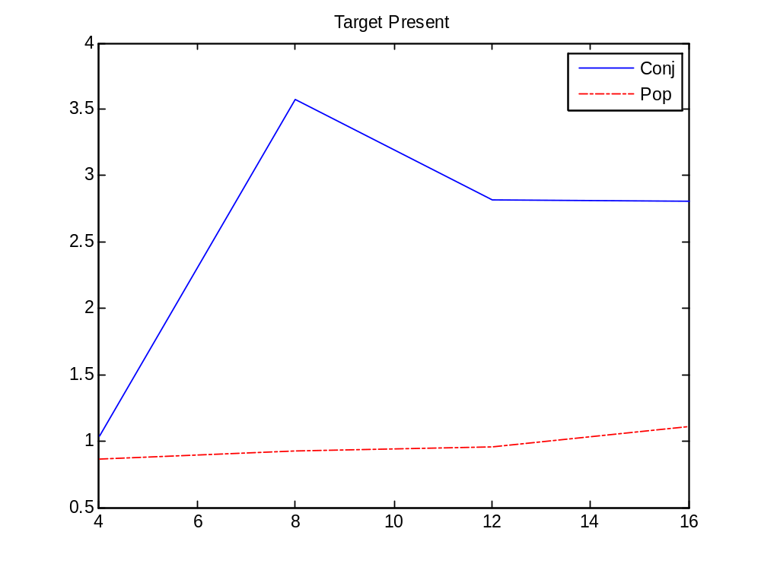
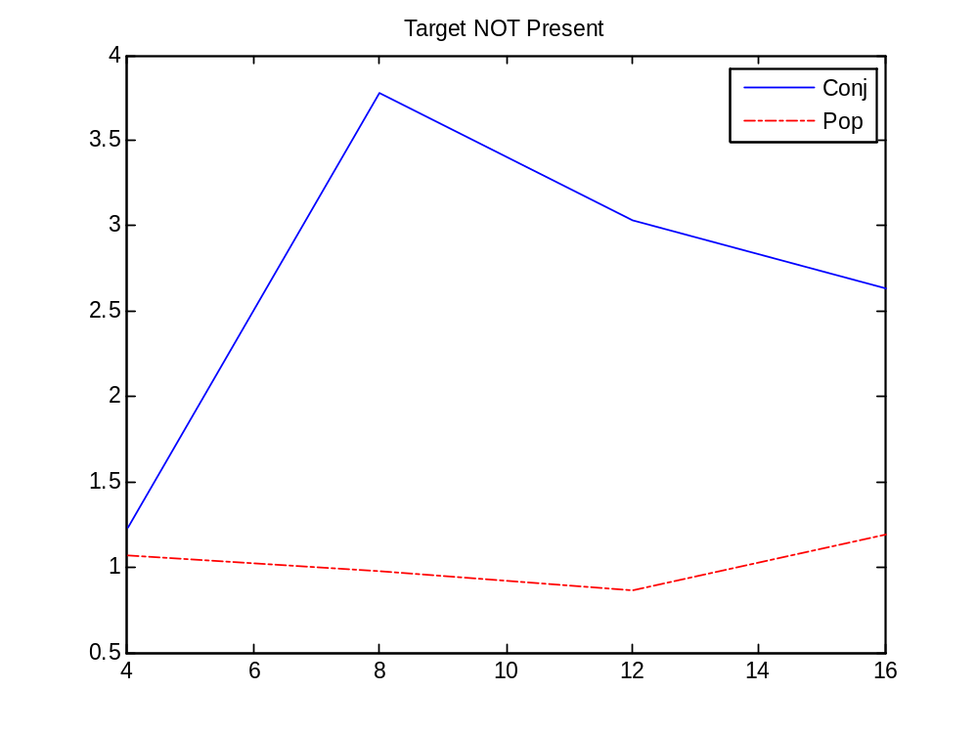
Pearson coefficients:

Conj, Target: 0.54
Conj, No Target: 0.41
Pop-out, Target: 0.94
Pop-out, Non Target: 0.22

Qualitatively, the slops of the reaction time vs. set size was fairly flat for the Pop-Out effect. For the Conjunction search, the reaction did increase as the set-size went from 4 to 8 objects, but then the reaction time decreased as the number of objects increased. This is at odds with the Treisman study.

One explanation is that my strategy for the large set size Conjunction searches was to reduce it to two serial Pop-Out searches. That is, I just concentrated on the red objects, and saw if one symbol popped out. Then I looked at the green objects and did the same. If between the two colors there was one and only one symbol pop-out, then the target was present. For some reason, this seemed to become easier with a larger number of objects, though that may have just been due to practice.

